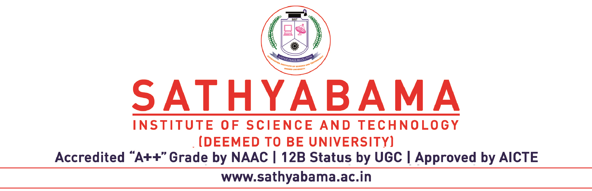

Request for Conduct of Extension Meeting beyond the Maximum Duration of Ph.D Programme
(To be filled in by the supervisor) Date:_____________

1. Name of Research Scholar: …………………………………

2. Reg. No: ………………………………..

3. Programme:

Name of Supervisor & Address (Mobile No. & Mail Id ) to which the communication is to be sent regarding contact of Extension Meeting
Name of the DC Members & Address (Mobile No. & Mail Id ) to which the communication is to be sent regarding contact of Extension Meeting | 1. | 2.
4. Research Status:
Duration of Ph.D Programme | From: ………………………… To: ………………………….
Any Break of Study given during the period of study | If Yes From: ………………………… To: ……………………
Request for Extension (Not exceeding Six Months) | From: ………………………… To: …………………………
Progress made with publication details:
Reason for Extension:
(Justifications to be enclosed & Certified by Supervisor)
List of Publications made so far should be enclosed.

Signature of Supervisor: ____________________________

For the office use only
Recommendations from Board of Research: Recommended / Not Recommended

Signature & Name
of the Member Secretary

